Exotic European Options

#



**Main Exotics**

# Asian Options

* Options whose payoff depends on the **average price** of the underlying over a period
  + Refers to either the **Arithmetic** or **Geometric** average of the stock price
  + The **initial stock price is excluded** from the average as it is known at the point of purchase
* Since the payoff is dependent on the prices leading up to price on maturity, it is **Path Dependent**

|  |  |
| --- | --- |
| **Average Price Option** | **Average Strike Option** |
| **Replace final stock price** with the average | **Replace strike price** with the average |
|  |  |
|  |  |



**Asian Option Price < European Option Price**

# Barrier Option

* Option that goes **into or out of existence** if the price of the underlying reaches a **specified barrier** during the life of the option
  + **Knock In Option** → Currently does not exist but gets **knocked into existence** once
  + **Knock Out Option** → Currently exists but gets **knocked out of existence**
  + **Rebate Option →** Fixed payout
  + Note that the underlying's price **does NOT need to stay above the barrier**; it could reach the barrier and then change in the opposite direction
* **Once** knocked in or out, then the price of the Barrier option at the time **must be equivalent** to the underlying Call or Put Option or **nothing if knocked out**
* Since the payoff is dependent on the price leading up to the price on maturity, it is **Path Dependent**

|  |  |  |  |
| --- | --- | --- | --- |
|  | **Knock In Option** | **Knock Out Option** | **Rebate Option** |
| **Barrier below Initial Price** | Down and In | Down and Out | Up Rebate |
| **Barrier above Initial Price** | Up and In | Up and Out | Down Rebate |

**When doing Binomial Tree issues to ONLY consider nodes where the barrier has been crossed**

## Barrier Option Put Call Parity

* Consider a portfolio of a Knock In and Knock Out Option - at any one time, **only one of the options will exist**
* Thus, the portfolio will always have a payoff equivalent to that of an ordinary option



Up-and-in call + Up-and-out call = Ordinary call 
Down-and-in call -+- Down-and-out call = Ordinary call 
Up-and-in put -+- Up-and-out put — 
Ordinary put 
Down-and-in put + Down-and-out put — Ordinary put 

## Special Case

|  |  |
| --- | --- |
| **Up and In Call** | **Down and In Put** |
| 6.2.2.1 | 6.2.2.2 |
| If the strike is above the barrier, it means that the call will only have value above the barrier    Thus, an Up and Out Call will be worthless as the call will never be exercised below the barrier, and if it does cross the barrier it will be knocked out    Up and Out Call = 0 | If the strike is below the barrier, that means that the put will only have value below the barrier    Thus, a Down and Out Put will be worthless as the put will never be exercised above the barrier, and it does cross the barrier it will be knocked out    Down and Out Put = 0 |

# Compound Option

* Option whose **underlying is another option** - Allows the owner to trade **another option** at a specified strike price at maturity
* 
  + 
  + 
* 
* The overall **profit of the Compound Option** is the Payoff of the underlying option LESS the price paid for both the Compound Option itself and the underlying Option

|  |  |  |
| --- | --- | --- |
|  | **Underlying is a Call** | **Underlying is a Put** |
| **Option to Buy** | Call on Call | Call on Put |
| **Option to Sell** | Put on Call | Put on Put |

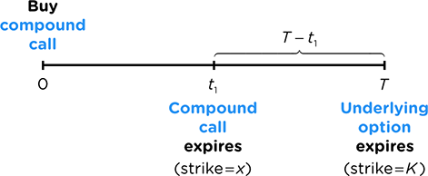

## Compound Option Put Call Parity

* Similarly, we can just replace the components of the **Put Call Parity Equation** to reflect a regular option being the underlying



## Compound Option Price Bounds

* Recall from an earlier section that an **Option cannot be worth more than the stock at the time**
* Thus, a Compound Option on an Option CANNOT be worth more than the underlying Option at the time

# Gap Option

* Option in which the price that determines whether or not the option will have a non-zero payoff **may be different** from the price that determines the non-zero payoff, creating a **gap**
  + 
  + 

|  |  |
| --- | --- |
| **Gap Call** | **Gap Put** |
|  |  |



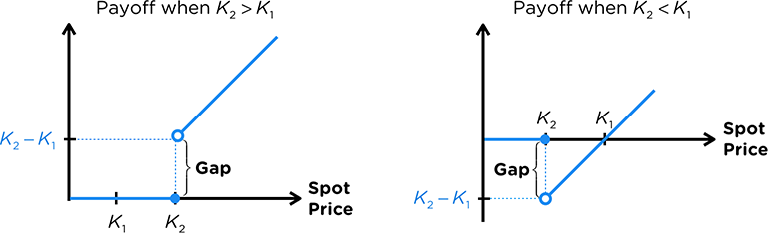

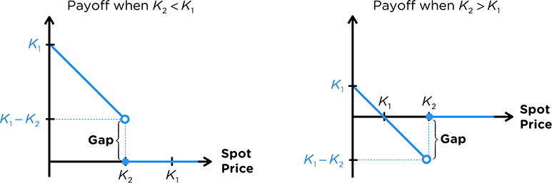

## Gap Option Black Scholes

* Notice that the Black Scholes formula is essentially an **expectation** formula:
  + 
  + 
* 

Through manipulation, we can link the regular Call & Put price to the Gap one:

|  |  |
| --- | --- |
| **Gap Call** |  |
| **Gap Put** |  |

## Gap Option Put Call Parity

* Consider a portfolio with a Long Gap Call and Short Gap Put
* One Option will always be exercised while the other will not, making the **payoff of the portfolio fixed**



Assuming no Arbitrage, we obtain a **Put Call Parity equation** for Gap Options:



## Comparing to regular options

|  |  |
| --- | --- |
| **Trigger = Regular Strike** | **Strike = Regular Strike** |
| Compare Strike with Strike | Compare Trigger with Strike |
| Strike Price Condition | Option that starts paying off **earlier is better** |

# Exchange Option

* Option that allows the owner to exchange one asset A for another asset B
* We can think of all regular options as an Exchange option:
  + 
  + 
* Thus, we can generalize this for **any combination** of assets:
  + Call (Receive, Give Up)
  + Puts (Give Up, Receive)
  + 

We can also **generalize Put Call Parity**,



Since Calls and Puts give up the opposite things, this leads to **Exchange Option Duality**,







Similarly, this leads to **Exchange Option Scaling**,



Both options fundamentally still give up and receive the same amount of assets.

Thus, using the same concepts, we can use **Black Scholes** to price the option:

|  |  |
| --- | --- |
| **Exchange Call** | **Exchange Put** |
|  |  |

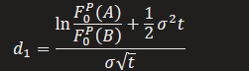



Note that since the second asset is no longer just cash, the variance of Volatility of the Option is more complicated. The volatility is calculated as the **Standard Deviation of returns** between the two assets:



**Payoff Manipulation**

# Payoff Manipulation

* Instead of directly stating the type of option, we may be only given the **payoff cashflows**
* Based on this, we need to **determine the combination of options or assets**
* The payoff cashflows will always be given in the form of a **Max or Min Function**
* The goal is to **manipulate the function** such that:
  + We obtain a **maximum function** that matches the payoff of a **Call or Put**
  + The **constant term** matches the payoff of a **Stock or Bond**
  + Based on the Cashflows, we can **determine the combination** of assets were used
* Note that there may be more than one combination of assets – this is because of Put Call Parity where **different combinations lead to the same outcome**

We can convert a Minimum to a Maximum by **changing the signs**:



We can change the components by **adding and subtracting a variable:**







A natural extension of the above result lets us obtain the following identity:



Additionally, we can **factor out coefficients** from any of the coefficients,



Finally, we can **add both together**,



## 

## Objective

* 
* 
* Alternatively, it could be to transform the expression into **something more familiar** to work with such as the Black Scholes or Put Call Parity formula

## Complicated Manipulations

* If more than one Maximum/Minimum Function is involved - Max within Max etc
* It is usually better to set the **inner maximum function as a variable** and work with it separately

Example:









# Creating our own Payoff functions

* Some questions may give us unique payoff diagrams that we have to find mathematical expressions for
  + **Positive Payoff** → Minimum Function
  + **Negative Payoff** → Maximum Function
* We can then manipulate it using the methods above to a more familiar option to work with

**Other Exotics**

# Forward Start Option

* It is a prepaid forward on an Option - it delivers the Option on maturity
* We can calculate the price of a chooser option using first principles:
  + Determine the price of the underlying option at time t
  + Discount the price to time 0 to obtain the price of the forward start option

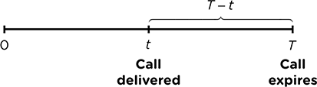

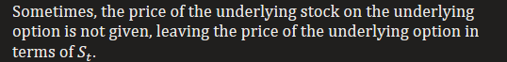



# Chooser Option

* Option that can be chosen to become either a Call or Put at maturity

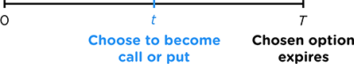

On the choosing date, choose the option with the highest value,



Manipulate the expression further,





Use **Put Call Parity** to further evaluate the expression,



We then find the time one value of these claims to price the Chooser option.

# Lookback Option

* An option whose payoff depends on the maximum or minimum of the stock price over the duration

|  |  |  |  |
| --- | --- | --- | --- |
|  | **Lookback Call** | **Lookback Put** |  |
| **Standard** |  |  | **Floating Strike Price** |
| **Extrema** |  |  | **Fixed Strike Price** |

# Shout Option

* Option where the owner can **guarantee a minimum payoff** exactly once
* The owner has the right to Shout - the minimum payoff becomes the **intrinsic value of the option at the time of the shout**
* No need to know how to price the option

|  |  |
| --- | --- |
| **Shout Call** | **Shout Put** |
|  |  |

# Rainbow Options

* Option whose payoff depends on **two or more *risky* assets**
  + All exchange options are Rainbow Options
  + Regular options are not Rainbow because Cash is not a risky asset
* It is called a rainbow option because it is a combination of multiple assets, just like a rainbow is a combination of various colours
* No need to know how to price the option